|  |  |  |
| --- | --- | --- |
|  | AptechIDCE160511H |  |

**Hydra Gaming Store**

**Analysis and Design Document**

**Team:** - Nguyễn Vũ Gia Huy

- Lê Nguyễn Phước Lộc

**Instructor:** Phan Hữu Trí

**Class:** ACCP-1806

**Date: 11/12/2019**

|  |  |  |
| --- | --- | --- |
| This is to certify that  Mr. / Ms.:        Has successfully designed, developed and hosted  Hydra Gaming Store  Submitted by:  Mr. Phan Hữu Trí  (Faculty Guilde’s Name and Signature) |  |  |



**Tables of contents**

**Content Page**

First Part: Introduction 01

1.

**Phần 1: Introduction**

1. **About my company**

* Hydra Gaming Store is an online store for shopping game accessories, games,…
* ………

1. **Hardware Required**
   * Server
     + PC PentiumIV
     + HDD 40GB
     + RAM 256MB
     + MODEM
   * Client
     + PC Pentium II
     + HDD 5GB
     + RAM 64MB
     + MODEM
2. **Software Required**
   * Server:
     + Window 2000 server
     + Access 2000
     + IIS 5.0
   * Client:
     + Window 98/2000/ME/XP
     + IE **Phần 2: Analysis - Design**
3. **Request Analysis:**
   1. Function Task
      1. Use Case:
      2. Flow chart:
   2. Hardware Required
   3. Hardware Required
4. **Database Design:**
   1. Tables:

* Table Name: Account,Category,Comment,Invoice,Invoice_detail, Product, Role,Role_Account
  1. ERD:

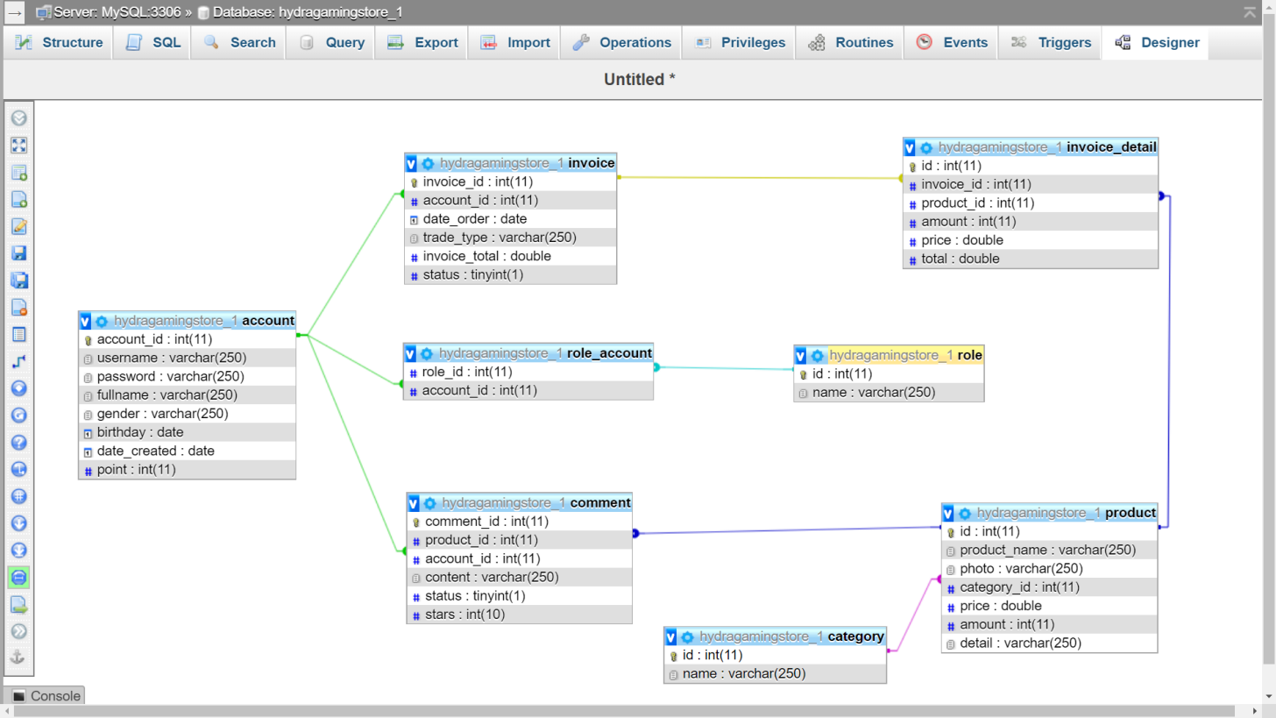

1. **Thiết kế Giao diện (GUI):**
   1. Site map (hoặc Màn hình chính của ứng dụng)
   2. Pages / Forms

* 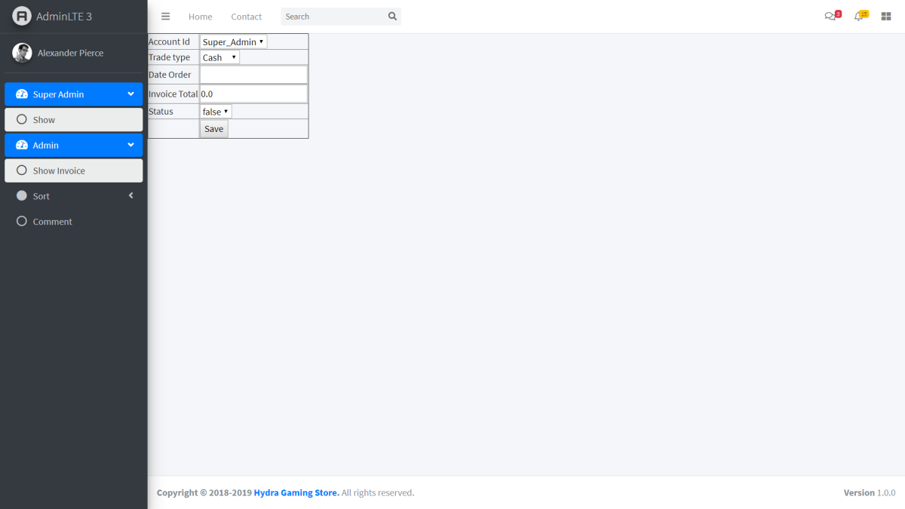
* Update invoice

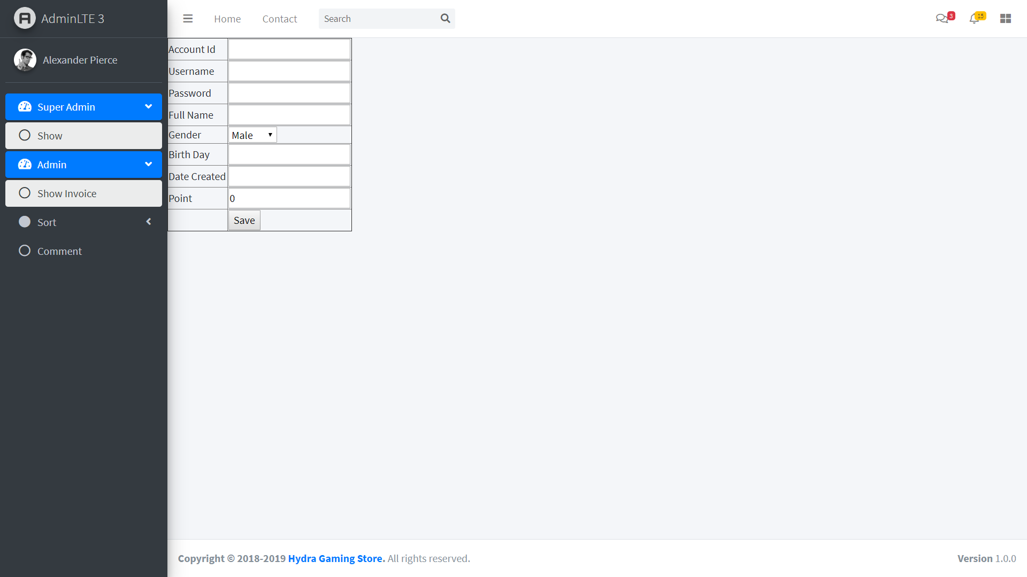

Add account

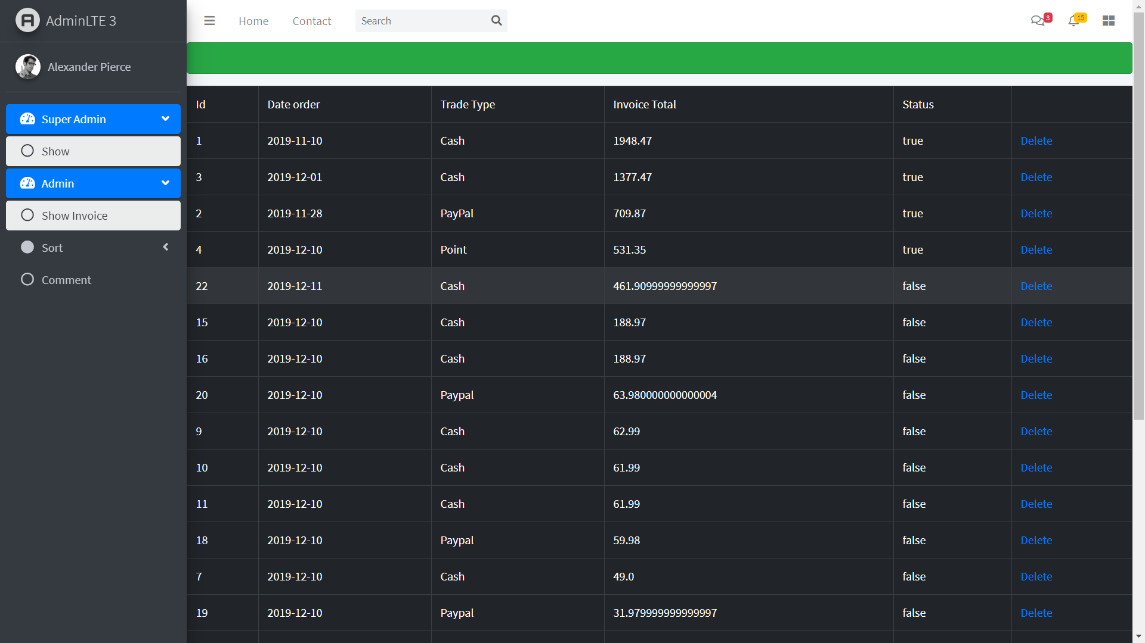

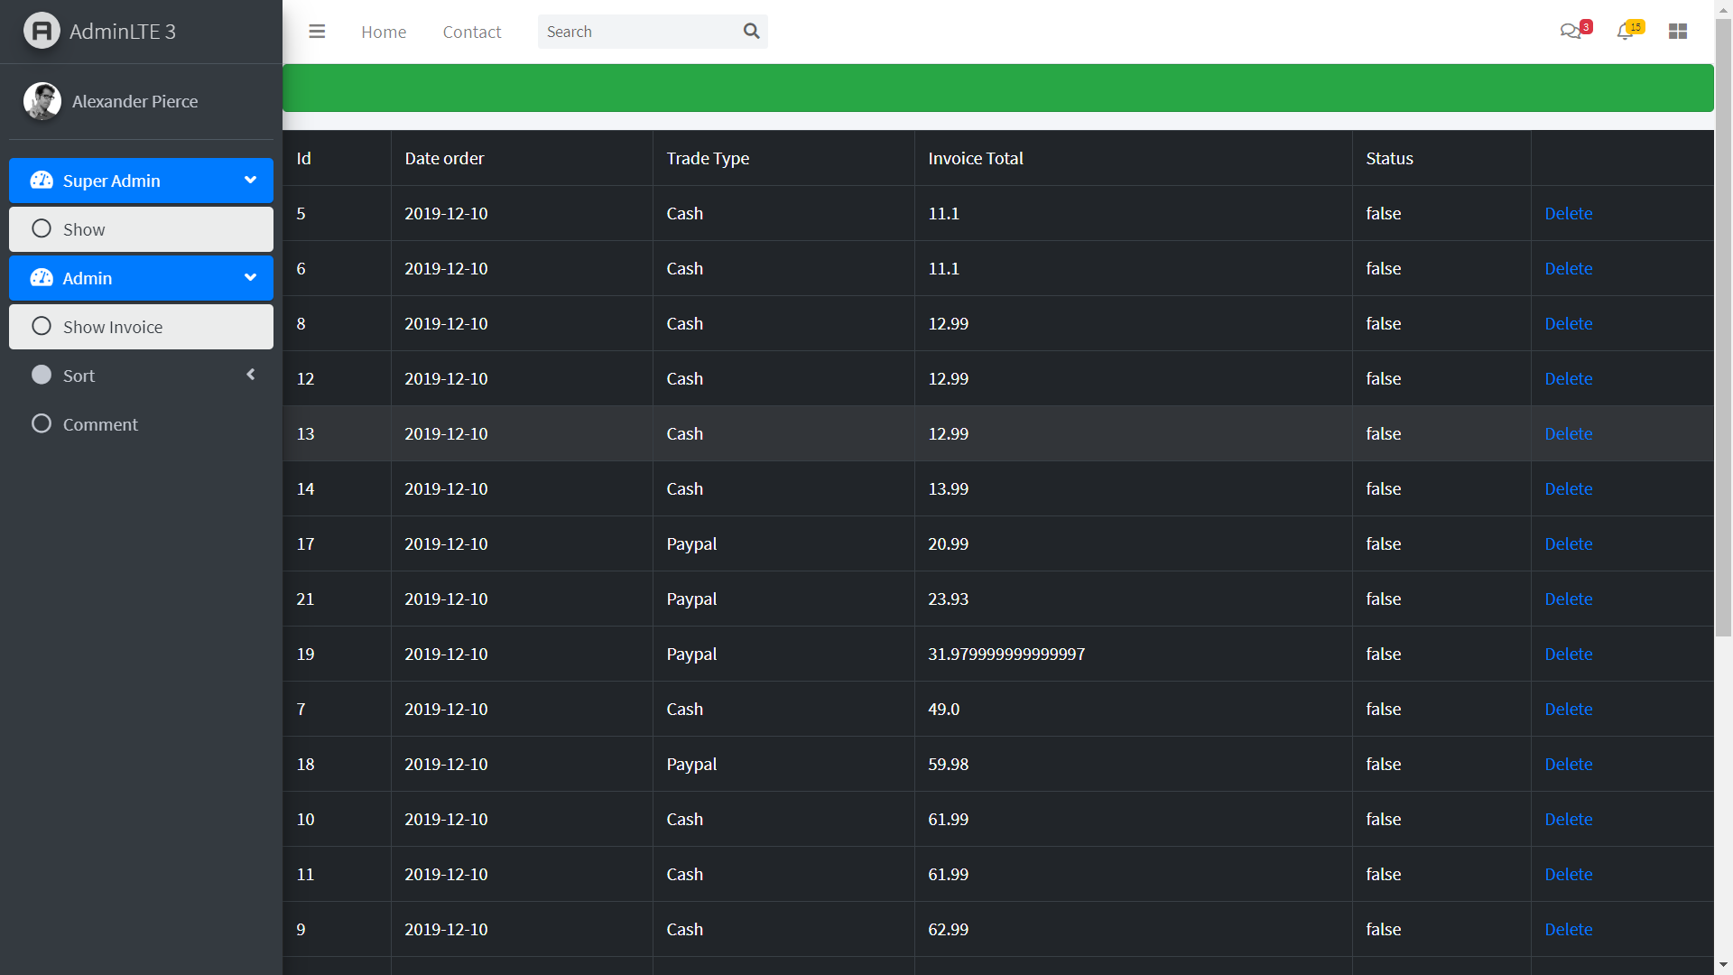

Show invoice by sort

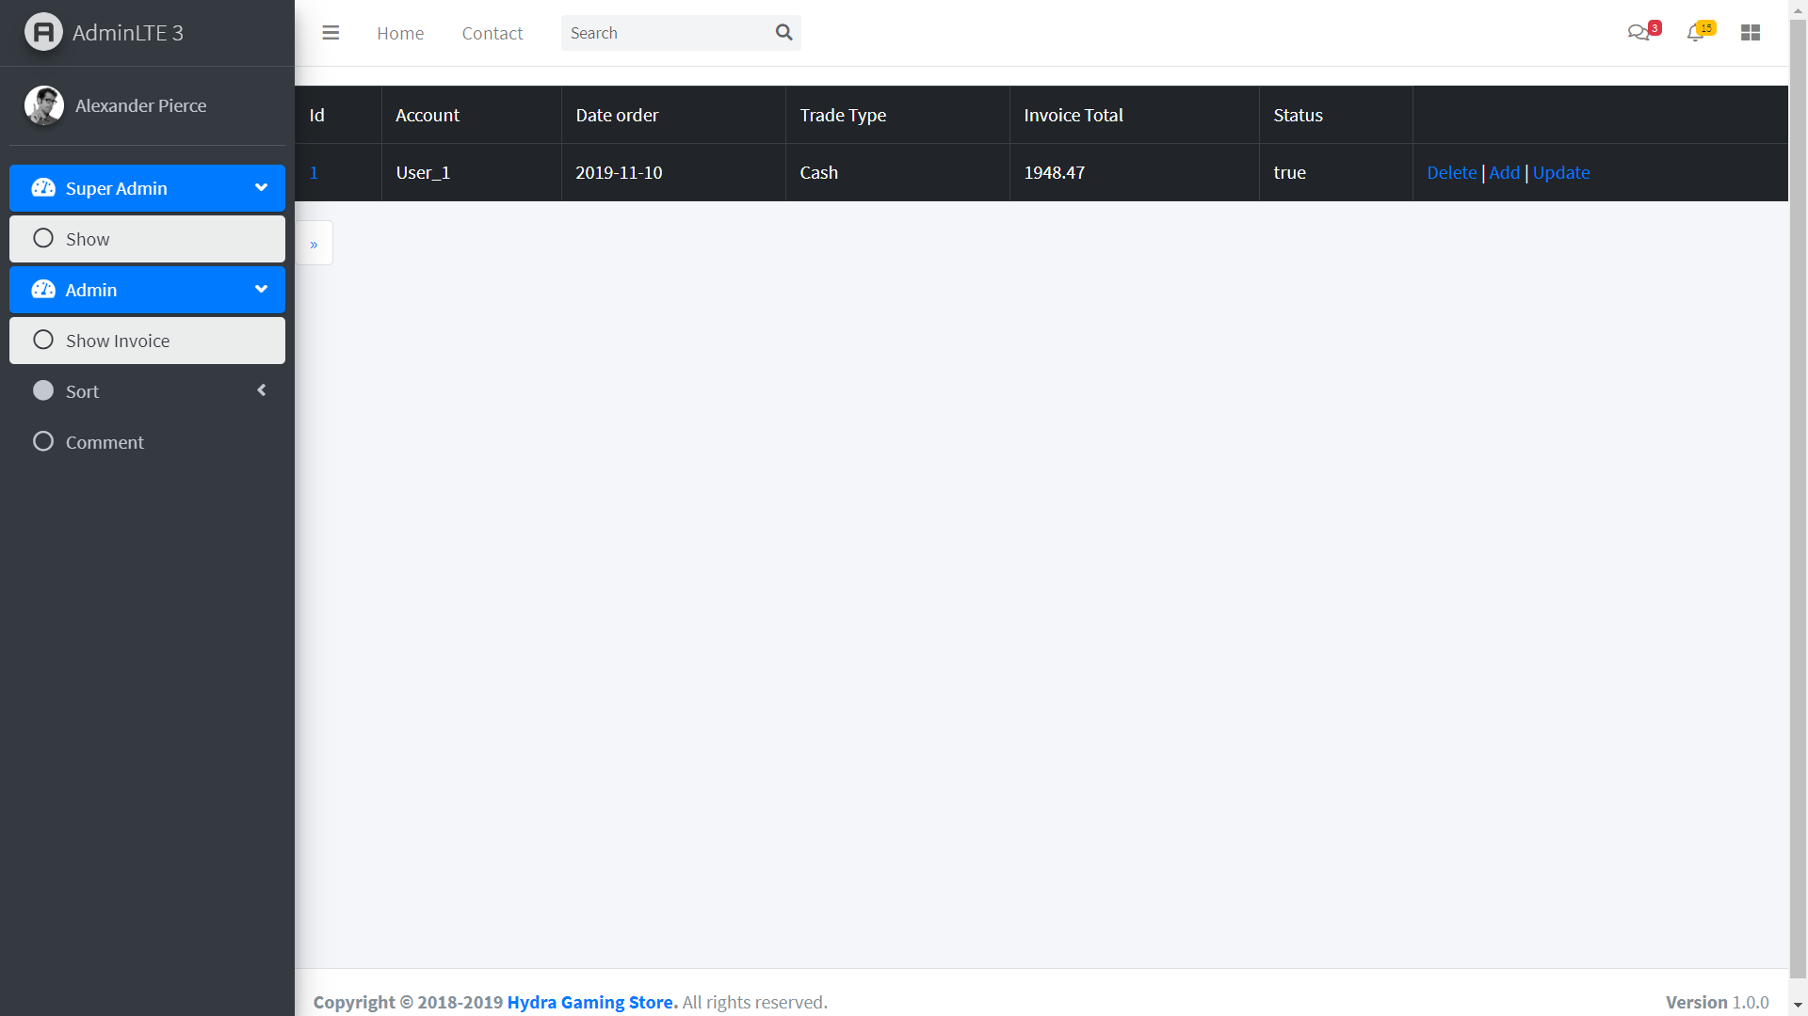

Show inovice

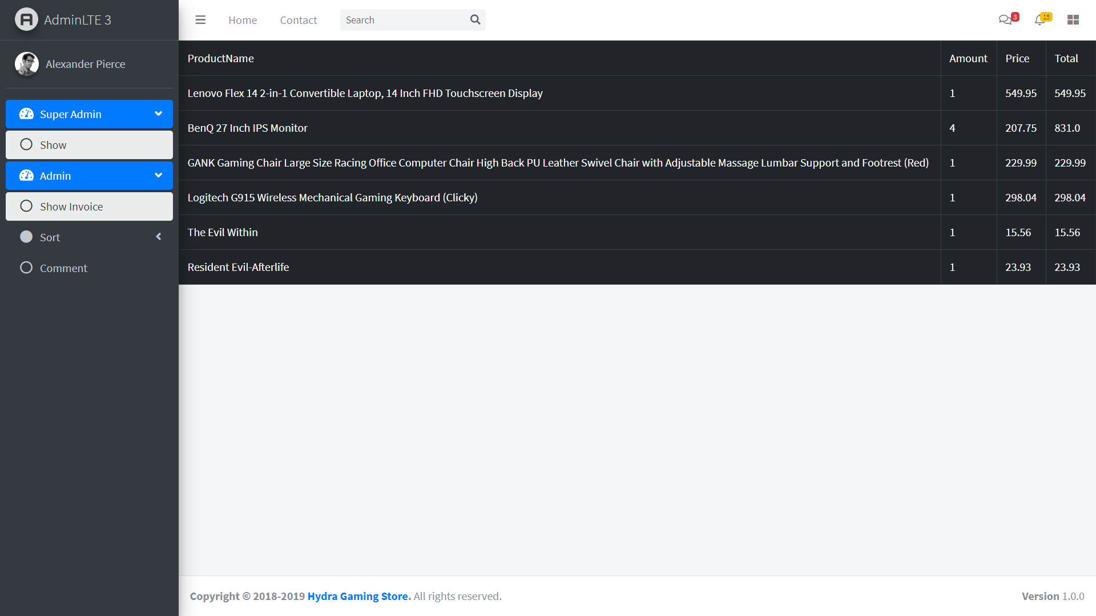

Show invoice detail

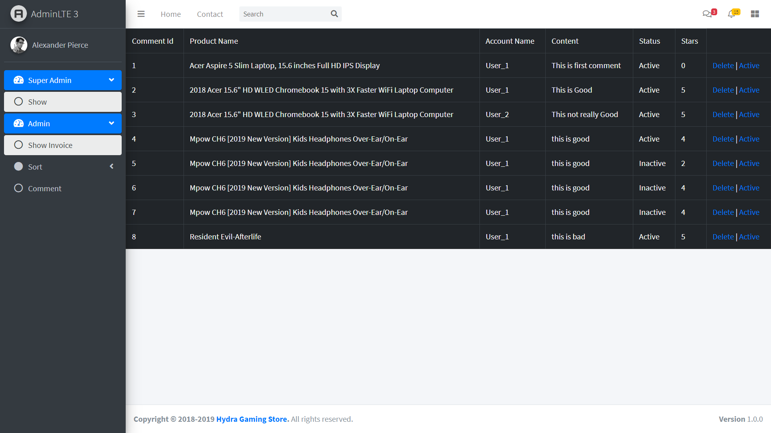

ShowComment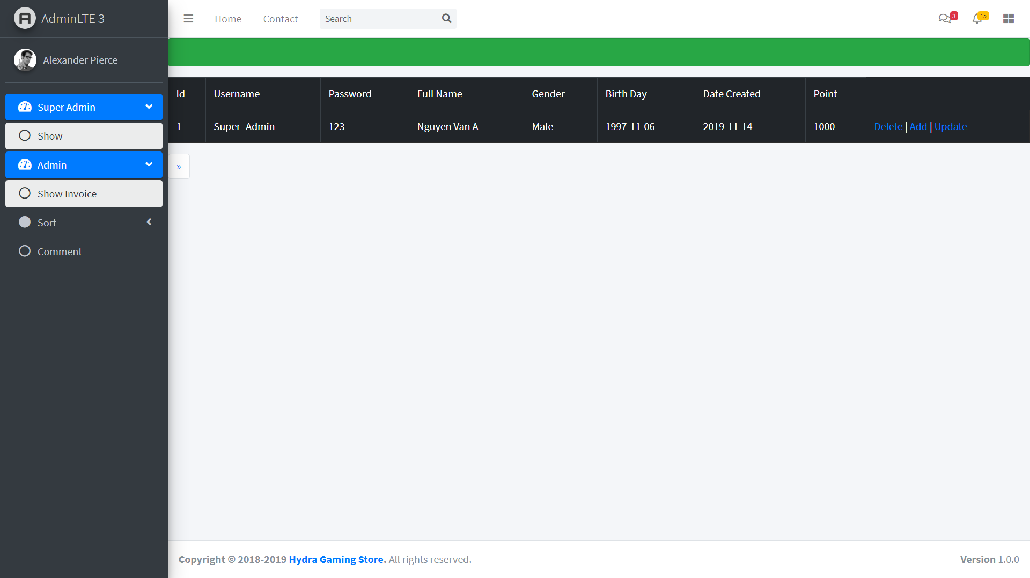

Show account



delete



Add account



Set active or inactive for comment

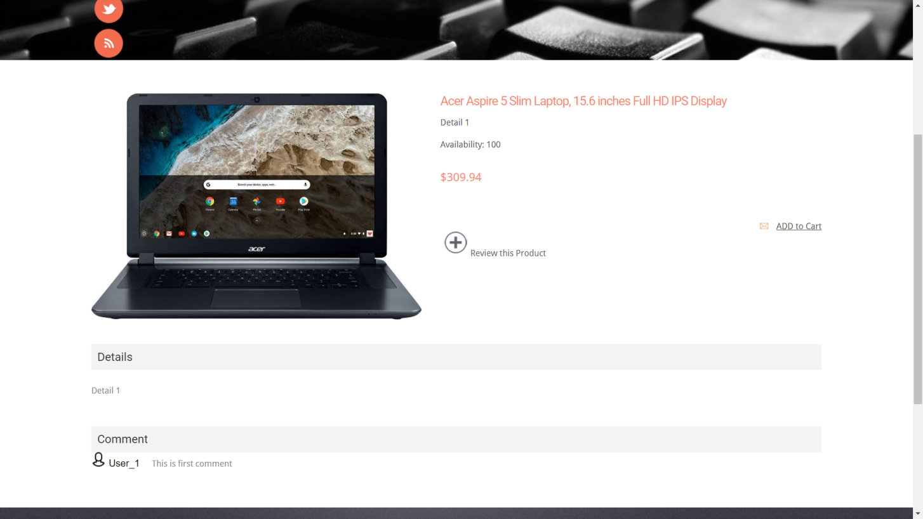

Show single product

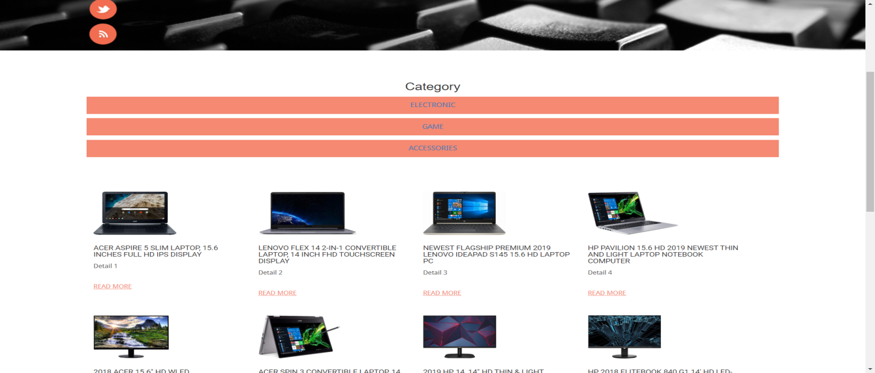

Show products by category

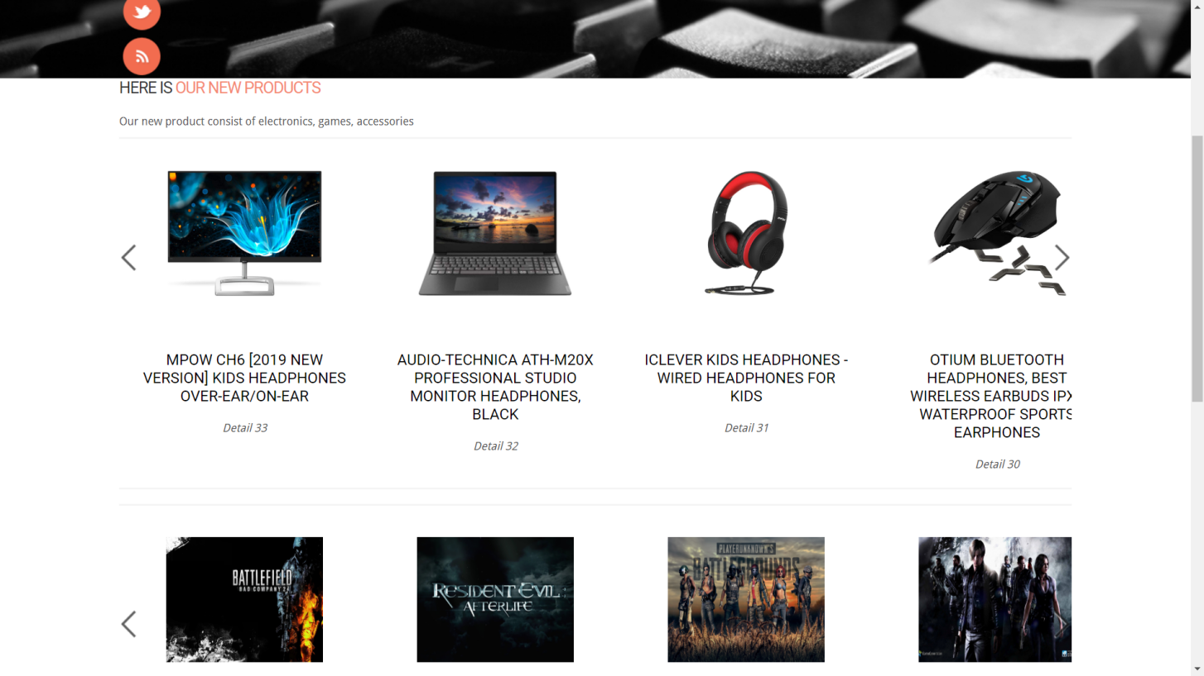

Show newest products by category

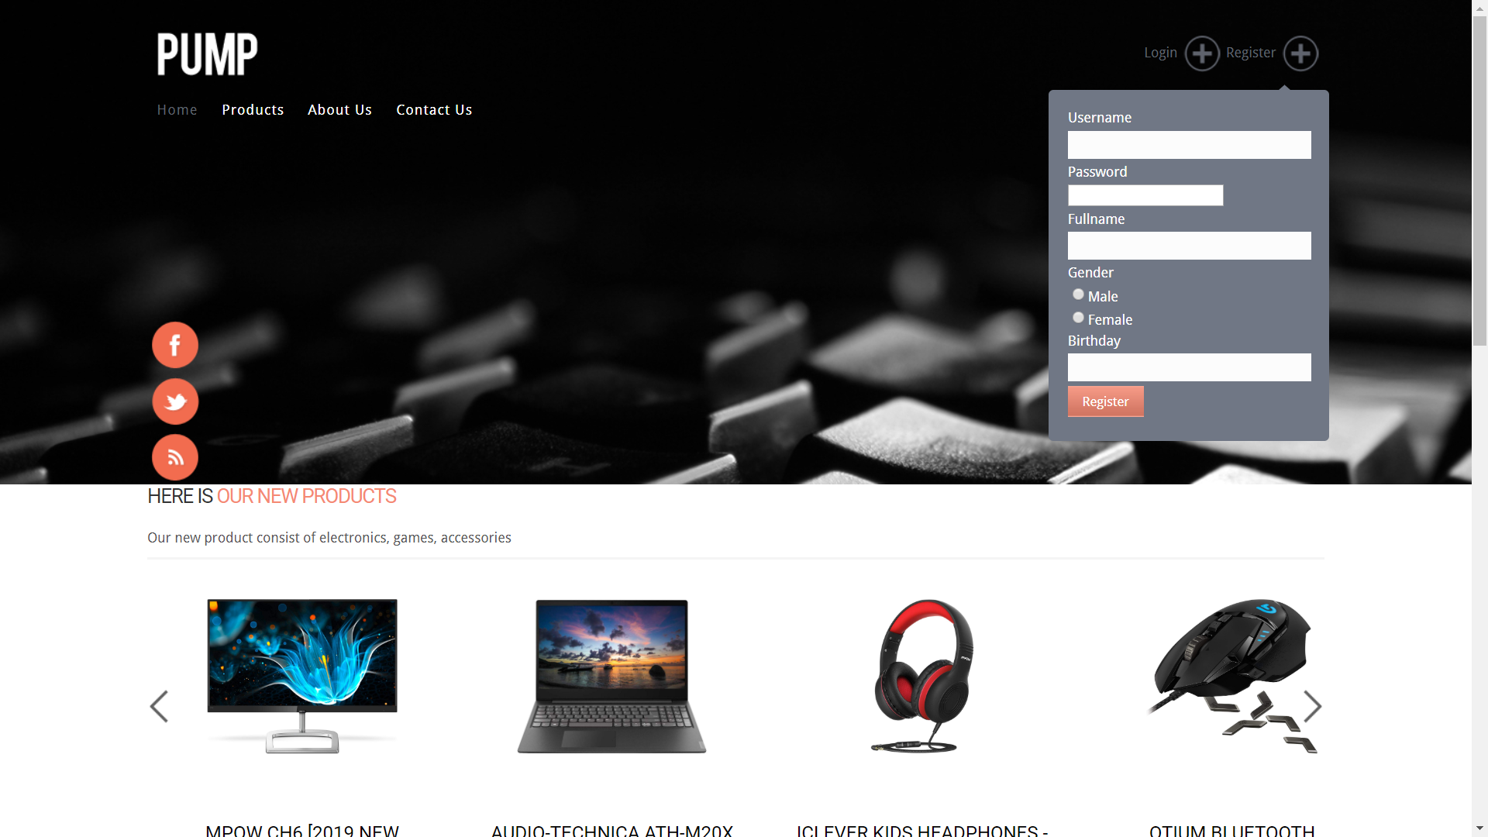

register

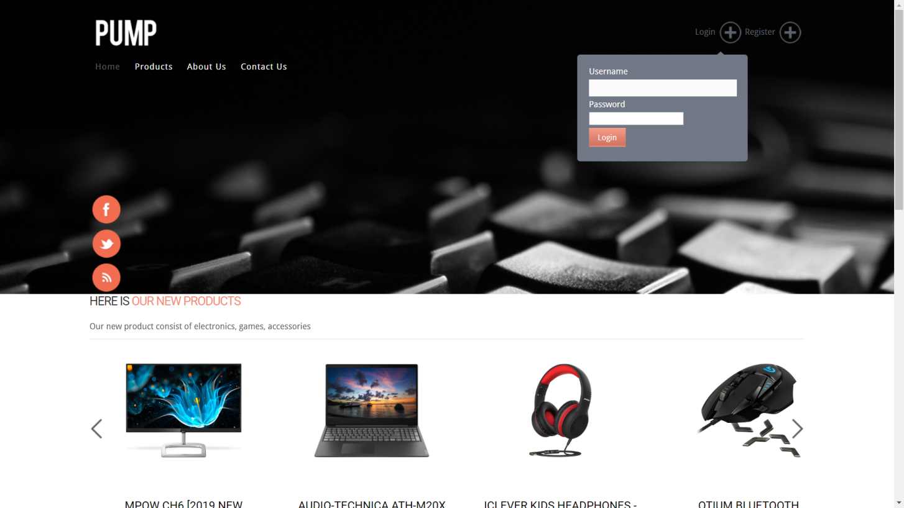

Login

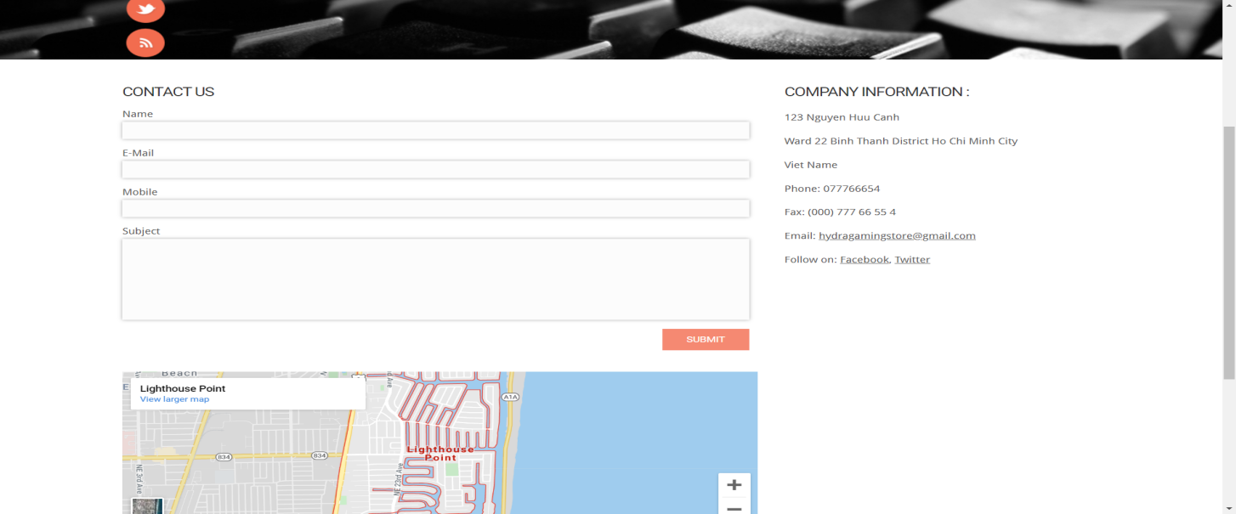

Contact us

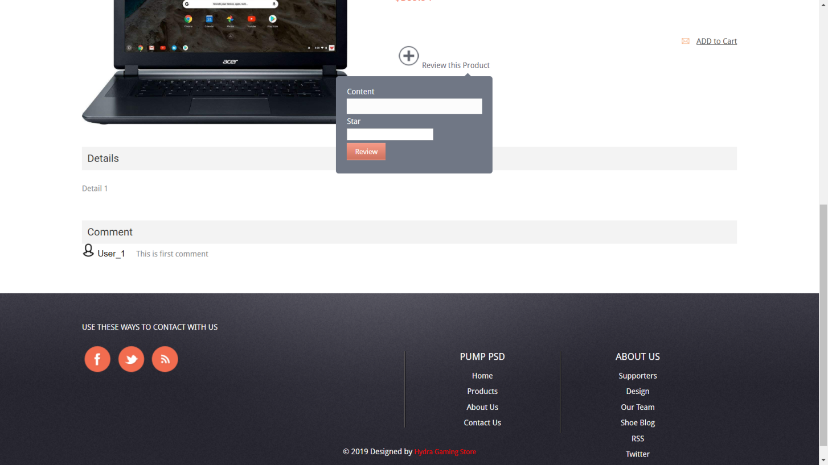

Post comment

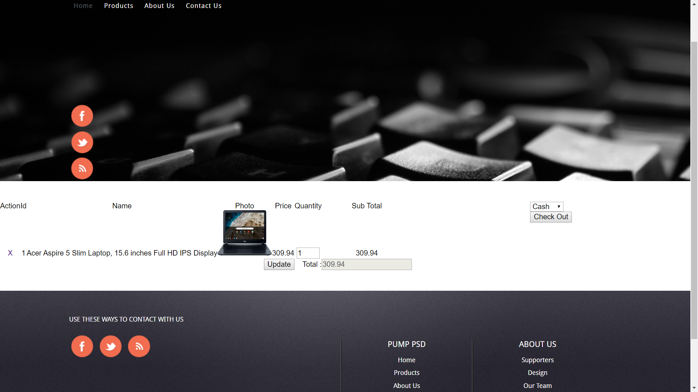

cart

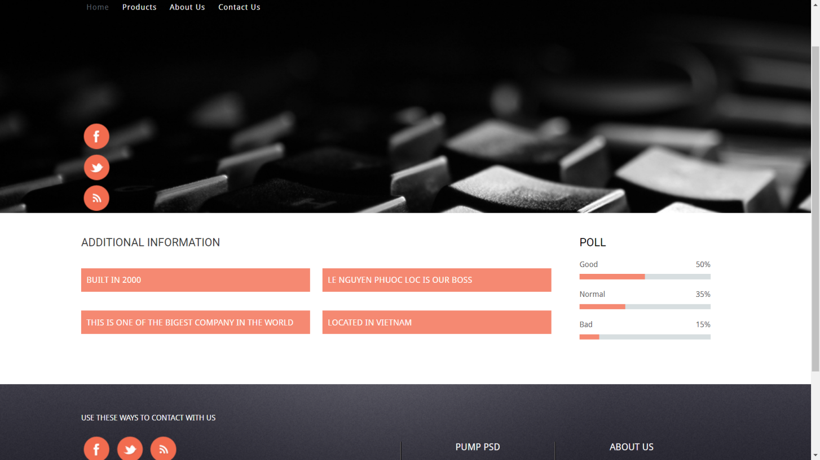

About us**Phần 3: Work Assignments**

|  |  |  |  |  |  |
| --- | --- | --- | --- | --- | --- |
| **Task** | **Estimated starting date** | **Starting Date** | **End Date** | **Member** | **Status** |
| -Login | 16/11/2019 | 17/11/2019 | 25/11/2019 | Lê Nguyễn Phước Lộc | Good |
| -CRUD (Admin  /SuperAdmin) | 16/11/2019 | 17/11/2019 | 23/11/2019 | Nguyễn Vũ Gia Huy | Good |
| -Cart | 16/11/2019 | 29/11/2019 | 4/12/2019 | Lê Nguyễn Phước Lộc | Good |
| -Sort(Admin) | 16/11/2019 | 25/11/2019 | 28/11/2019 | Nguyễn Vũ Gia Huy | Good |
| -Database Design | 16/11/2019 | 16/11/2019 | 18/11/2019 | Lê Nguyễn Phước Lộc | Good |
| -Find Data | 16/11/2019 | 16/11/2019 | 20/11/2019 | Nguyễn Vũ Gia Huy | Good |
| -Pagination  (Admin  /SuperAdmin) | 16/11/2019 | 3/12/2019 | 8/12/2019 | Nguyễn Vũ Gia Huy | Good |
| -Pagination  (User) | 16/11/2019 | 3/12/2019 | 7/12/2019 | Lê Nguyễn Phước Lộc | Good |
| -Secuirity | 16/11/2019 | 7/12/2019 | 11/11/2019 | Lê Nguyễn Phước Lộc | Good |